INSERT INTO users (name, email, password_hash, role_id) VALUES
('Alejandro García', 'alejandro.garcia@email.com', 'password123', 1),
('María Rodríguez', 'maria.rodriguez@email.com', 'password123', 1),
('Javier López', 'javier.lopez@email.com', 'password123', 1),
('Lucía Martínez', 'lucia.martinez@email.com', 'password123', 1),
('Carlos Sánchez', 'carlos.sanchez@email.com', 'password123', 1),
('Elena Pérez', 'elena.perez@email.com', 'password123', 1),
('Miguel Gómez', 'miguel.gomez@email.com', 'password123', 1),
('Sofía Martín', 'sofia.martin@email.com', 'password123', 1),
('David Jiménez', 'david.jimenez@email.com', 'password123', 1),
('Paula Ruiz', 'paula.ruiz@email.com', 'password123', 1),
('Sergio Hernández', 'sergio.hernandez@email.com', 'password123', 1),
('Carmen Díaz', 'carmen.diaz@email.com', 'password123', 1),
('Andrés Moreno', 'andres.moreno@email.com', 'password123', 1),
('Isabel Muñoz', 'isabel.munoz@email.com', 'password123', 1),
('Diego Álvarez', 'diego.alvarez@email.com', 'password123', 1),
('Ana Romero', 'ana.romero@email.com', 'password123', 1),
('Pablo Alonso', 'pablo.alonso@email.com', 'password123', 1),
('Marta Gutiérrez', 'marta.gutierrez@email.com', 'password123', 1),
('Marcos Navarro', 'marcos.navarro@email.com', 'password123', 1),
('Laura Torres', 'laura.torres@email.com', 'password123', 1),
('Adrián Domínguez', 'adrian.dominguez@email.com', 'password123', 1),
('Julia Vázquez', 'julia.vazquez@email.com', 'password123', 1),
('Raúl Ramos', 'raul.ramos@email.com', 'password123', 1),
('Sara Gil', 'sara.gil@email.com', 'password123', 1),
('Fernando Ramírez', 'fernando.ramirez@email.com', 'password123', 1),
('Irene Serrano', 'irene.serrano@email.com', 'password123', 1),
('Hugo Blanco', 'hugo.blanco@email.com', 'password123', 1),
('Alba Molina', 'alba.molina@email.com', 'password123', 1),
('Jorge Morales', 'jorge.morales@email.com', 'password123', 1),
('Clara Suárez', 'clara.suarez@email.com', 'password123', 1),
('Roberto Ortega', 'roberto.ortega@email.com', 'password123', 1),
('Natalia Delgado', 'natalia.delgado@email.com', 'password123', 1),
('Rubén Castro', 'ruben.castro@email.com', 'password123', 1),
('Beatriz Ortiz', 'beatriz.ortiz@email.com', 'password123', 1),
('Álvaro Marín', 'alvaro.marin@email.com', 'password123', 1),
('Silvia Rubio', 'silvia.rubio@email.com', 'password123', 1),
('Óscar Núñez', 'oscar.nunez@email.com', 'password123', 1),
('Cristina Medina', 'cristina.medina@email.com', 'password123', 1),
('Iván Castillo', 'ivan.castillo@email.com', 'password123', 1),
('Andrea Cortés', 'andrea.cortes@email.com', 'password123', 1);
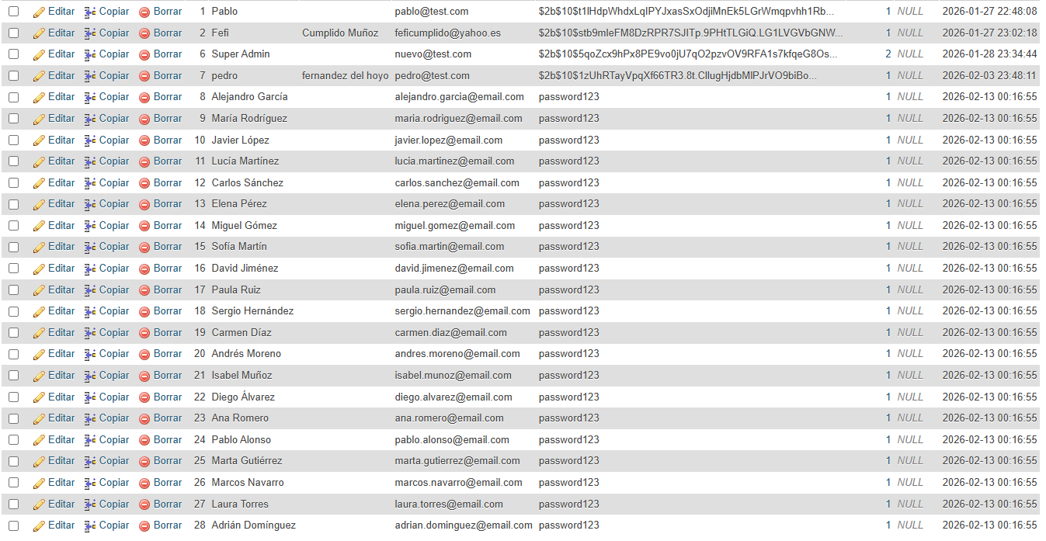
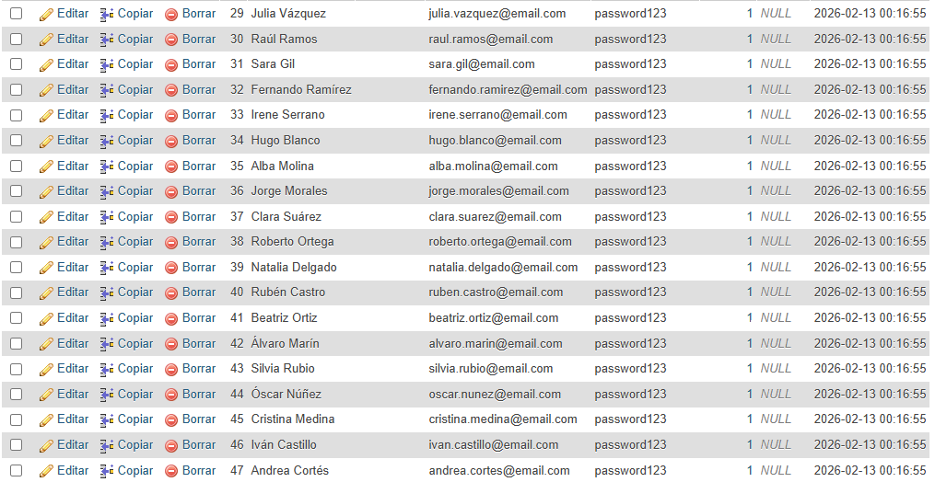
-- 1. Limpiamos las pistas actuales para evitar duplicados o IDs mezclados
TRUNCATE TABLE courts;

-- 2. Insertamos las 12 pistas de PÁDEL
INSERT INTO courts (name, type, surface, active, opening_time, closing_time) VALUES
('Padel Central 1', 'padel', 'Césped Premium PP', 1, '08:00:00', '23:00:00'),
('Padel Central 2', 'padel', 'Césped Premium PP', 1, '08:00:00', '23:00:00'),
('Padel 3', 'padel', 'Césped Azul', 1, '08:00:00', '23:00:00'),
('Padel 4', 'padel', 'Césped Azul', 1, '08:00:00', '23:00:00'),
('Padel 5', 'padel', 'Césped Azul', 1, '08:00:00', '23:00:00'),
('Padel 6', 'padel', 'Césped Azul', 1, '08:00:00', '23:00:00'),
('Padel 7', 'padel', 'Césped Azul', 1, '08:00:00', '23:00:00'),
('Padel 8', 'padel', 'Césped Azul', 1, '08:00:00', '23:00:00'),
('Padel 9', 'padel', 'Césped Azul', 1, '08:00:00', '23:00:00'),
('Padel 10', 'padel', 'Césped Azul', 1, '08:00:00', '23:00:00'),
('Padel 11', 'padel', 'Césped Verde', 1, '08:00:00', '23:00:00'),
('Padel 12', 'padel', 'Césped Verde', 1, '08:00:00', '23:00:00');

-- 3. Insertamos las 4 pistas de TENIS
INSERT INTO courts (name, type, surface, active, opening_time, closing_time) VALUES
('Tenis Central', 'tenis', 'Tierra Batida', 1, '08:00:00', '22:00:00'),
('Tenis 2', 'tenis', 'Resina (Rápida)', 1, '08:00:00', '22:00:00'),
('Tenis 3', 'tenis', 'Resina (Rápida)', 1, '08:00:00', '22:00:00'),
('Tenis 4', 'tenis', 'Césped Art.', 1, '08:00:00', '22:00:00');
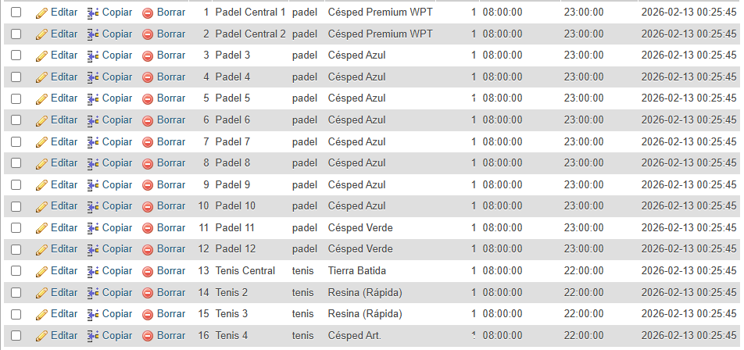
-- 1. Limpiamos reservas previas para no solapar
SET FOREIGN_KEY_CHECKS = 0;
TRUNCATE TABLE reservations;
SET FOREIGN_KEY_CHECKS = 1;

-- 2. Insertamos las 6 reservas específicas para PABLO (User ID: 1)
INSERT INTO reservations (user_id, court_id, date, start_time, end_time, status) VALUES
(1, 1, '2026-02-14', '10:00:00', '11:30:00', 'confirmed'),
(1, 13, '2026-02-16', '18:00:00', '19:30:00', 'confirmed'),
(1, 2, '2026-02-20', '09:00:00', '10:30:00', 'confirmed'),
(1, 14, '2026-02-22', '11:00:00', '12:30:00', 'confirmed'),
(1, 5, '2026-02-25', '20:00:00', '21:30:00', 'confirmed'),
(1, 1, '2026-02-28', '17:00:00', '18:30:00', 'confirmed');

-- 3. Insertamos 54 reservas aleatorias para el resto de usuarios
-- Nota: Usamos una mezcla de IDs de usuario (2 al 41) y pistas (1 al 16)
INSERT INTO reservations (user_id, court_id, date, start_time, end_time, status) VALUES
(2, 3, '2026-02-13', '17:00:00', '18:30:00', 'confirmed'),
(3, 15, '2026-02-13', '19:00:00', '20:30:00', 'confirmed'),
(4, 1, '2026-02-14', '12:00:00', '13:30:00', 'confirmed'),
(5, 13, '2026-02-14', '10:00:00', '11:30:00', 'confirmed'),
(6, 4, '2026-02-15', '09:00:00', '10:30:00', 'confirmed'),
(7, 2, '2026-02-15', '18:30:00', '20:00:00', 'confirmed'),
(8, 16, '2026-02-16', '17:00:00', '18:30:00', 'confirmed'),
(9, 6, '2026-02-16', '20:00:00', '21:30:00', 'confirmed'),
(10, 1, '2026-02-17', '11:00:00', '12:30:00', 'confirmed'),
(11, 14, '2026-02-17', '18:00:00', '19:30:00', 'confirmed'),
(12, 7, '2026-02-18', '09:00:00', '10:30:00', 'confirmed'),
(13, 13, '2026-02-18', '21:00:00', '22:30:00', 'confirmed'),
(14, 8, '2026-02-19', '17:30:00', '19:00:00', 'confirmed'),
(15, 2, '2026-02-19', '19:30:00', '21:00:00', 'confirmed'),
(16, 15, '2026-02-20', '10:00:00', '11:30:00', 'confirmed'),
(17, 9, '2026-02-20', '18:00:00', '19:30:00', 'confirmed'),
(18, 1, '2026-02-21', '09:00:00', '10:30:00', 'confirmed'),
(19, 13, '2026-02-21', '12:00:00', '13:30:00', 'confirmed'),
(20, 10, '2026-02-22', '17:00:00', '18:30:00', 'confirmed'),
(21, 3, '2026-02-22', '19:00:00', '20:30:00', 'confirmed'),
(22, 11, '2026-02-23', '08:30:00', '10:00:00', 'confirmed'),
(23, 16, '2026-02-23', '20:30:00', '22:00:00', 'confirmed'),
(24, 12, '2026-02-24', '17:00:00', '18:30:00', 'confirmed'),
(25, 4, '2026-02-24', '18:30:00', '20:00:00', 'confirmed'),
(26, 14, '2026-02-25', '11:00:00', '12:30:00', 'confirmed'),
(27, 2, '2026-02-25', '09:00:00', '10:30:00', 'confirmed'),
(28, 1, '2026-02-26', '21:00:00', '22:30:00', 'confirmed'),
(29, 15, '2026-02-26', '18:00:00', '19:30:00', 'confirmed'),
(30, 5, '2026-02-27', '17:00:00', '18:30:00', 'confirmed'),
(31, 13, '2026-02-27', '19:30:00', '21:00:00', 'confirmed'),
(32, 6, '2026-02-28', '10:00:00', '11:30:00', 'confirmed'),
(33, 16, '2026-02-28', '12:00:00', '13:30:00', 'confirmed'),
(34, 1, '2026-03-01', '17:00:00', '18:30:00', 'confirmed'),
(35, 13, '2026-03-01', '18:30:00', '20:00:00', 'confirmed'),
(36, 7, '2026-02-14', '20:00:00', '21:30:00', 'confirmed'),
(37, 2, '2026-02-15', '11:30:00', '13:00:00', 'confirmed'),
(38, 14, '2026-02-16', '09:00:00', '10:30:00', 'confirmed'),
(39, 8, '2026-02-17', '17:00:00', '18:30:00', 'confirmed'),
(40, 15, '2026-02-18', '19:00:00', '20:30:00', 'confirmed'),
(2, 9, '2026-02-19', '11:00:00', '12:30:00', 'confirmed'),
(3, 1, '2026-02-20', '20:30:00', '22:00:00', 'confirmed'),
(4, 13, '2026-02-21', '17:30:00', '19:00:00', 'confirmed'),
(5, 10, '2026-02-22', '10:00:00', '11:30:00', 'confirmed'),
(6, 2, '2026-02-23', '18:00:00', '19:30:00', 'confirmed'),
(7, 14, '2026-02-24', '09:00:00', '10:30:00', 'confirmed'),
(8, 11, '2026-02-25', '21:00:00', '22:30:00', 'confirmed'),
(9, 3, '2026-02-26', '17:00:00', '18:30:00', 'confirmed'),
(10, 16, '2026-02-27', '19:00:00', '20:30:00', 'confirmed'),
(11, 4, '2026-02-28', '11:00:00', '12:30:00', 'confirmed'),
(12, 1, '2026-03-01', '09:00:00', '10:30:00', 'confirmed'),
(13, 15, '2026-02-14', '18:30:00', '20:00:00', 'confirmed'),
(14, 5, '2026-02-15', '20:00:00', '21:30:00', 'confirmed'),
(15, 13, '2026-02-16', '10:00:00', '11:30:00', 'confirmed'),
(16, 6, '2026-02-17', '17:30:00', '19:00:00', 'confirmed');
